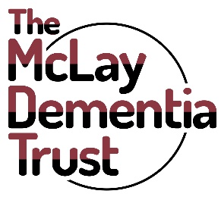 Registered Charity No: 1170225
GUIDANCE NOTES
The McClay Dementia Trust was created by Drs Sandra and Roger Duggan on 16th November 2016 in memory of May McLay, Sandra’s mother. Sandra’s career has been primarily in social care and research. More recently her work has been with NICE, NIHR, the Alzheimer’s Society and AgeUK (participating in inspections of care homes and domiciliary care services).

The Trustees have wide discretionary powers when resolving to make donations within the key objectives of the Charity:

- To improve care for people with dementia living at home or in residential care in the UK.
- To improve quality of life for people with dementia and their carers.
- To support the provision of meaningful activity for people with dementia in care homes, in their own homes or in the community.
- To support the provision of specialist services for people with dementia such as home care services or the Admiral Nurse service.

The trustees hold unrestricted funds and are able to apply all funds towards such charitable purposes and make donations to such charitable bodies or institutions at such times and in such manner as they in their absolute discretion think fit. Applications between £1,000 and £30,000 will be considered. There is an emphasis on supporting excellence in any chosen field enabling results to be achieved that would not otherwise without receiving the charity's support.

All Trustees enjoy playing an active role in the administration of the Trust, from researching potential donees to visiting charities and related events where applicable. They welcome such involvement to be able to follow how their funds are put to good use.

Grant applications are considered three times a year in March, July and November. Applications should therefore be submitted by the end of February, June or October.

All applications for funding should include the completed application form and a set of the most recent approved accounts and be e-mailed or sent by post to the charity's principal address, marked for the attention of Mrs Anna Frost. Please note that the Trustees may request additional information considered necessary on an individual basis. All applicants will be advised by email whether or not they have been successful.

Please note that a timely and detailed end of award report demonstrating how funding from the Trust has been spent and what impact it has made should be submitted at the end of the grant period. If a report is not received, any subsequent application will not be considered.

Postal address:, Rathbone Trust Co Ltd, 8 Finsbury Circus, London EC2M 7AZ
Email: anna.frost@rathbones.com.

